**[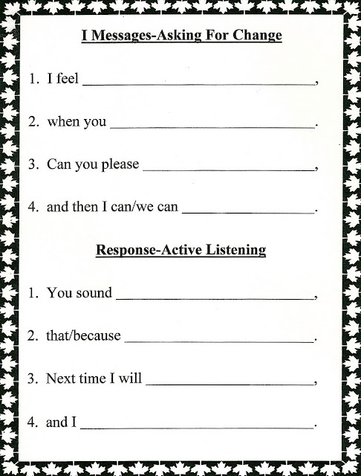](http://www.lorinda-charactereducation.com/p/i-messages-asking-for-change-and.html) [](http://www.lorinda-charactereducation.com/p/i-messages-asking-for-change-and.html)**